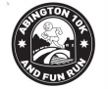
Abington 10k, 5K & Fun Run 2023
Race-Day Rules and Information
Sunday 6 October 2024. Start 10:30am at Granta Park
We look forward to seeing you for the Abington 10k, 5K & Fun Run 2023. The details below contain important information for the event which you need to be aware of before deciding whether to enter and then to reacquaint yourselves with before race day. This year the maximum number of runners is 500 for the 10K, 300 for the 5K and 200 for the Fun Run.
Arrival
Start and finish for the races is in the vicinity of the TWI building in Granta Park. There is plenty of parking. Please set your Satnav to CB21 6GP. For additional directions see www.grantapark.co.uk. Please note that Pampisford Road will be closed for the race between the top of Great Abington High Street and the Granta Park roundabout. The gate on the footpath from Great Abington High Street will be open for the day.
Before the Start
- Race numbers will be posted to runners a few days before the event.
- Please fix your race number to the front of your shirt in four corners before you come to the event. Spare safety pins are available if required on the day. Please ensure that your emergency and relevant medical information is filled in on the back of the race number.
IMPORTANT: if you have multiple runners in the events within your household, the envelopes have the runners name on, (the bibs do not). Please ensure you name each bib as you remove them from the envelopes. Having the wrong bibs will affect the chip timing and potentially who wins each race category.
- All races use chip timing. The timing chip is fixed to your race number and will register your start and finish.
- A baggage facility is available for you which will also offer to hold car keys during the race.
- Toilets are located near the start.
- Should you drop out during the race, please inform the nearest marshal. If necessary, a medical response team is in attendance.
- If you cannot compete we will accept name changes until 22.30 on 29 September by email to abington10k@gmail.com. Unfortunately, we are not able to give you a refund.
- The 10k, 5K & Fun Run are held under UK Athletic Rules and are UKA Licenced.

Risk Advice
- Runners are advised to warm-up before the start to reduce the risk of injury.
- Runners and spectators must not attend the event if they have been unwell or suffering from Covid symptoms, had a positive test or have been in contact with someone who has had a positive test result.
- Children as spectators or participants are the responsibility of their parents/carers at all times, including during the Fun Run.
- Should children get lost, please contact the Race Headquarters for help.
- Part of the 10k route takes the runners on public roads, and runners are advised that they do not have priority over other road users and must give way in the event of conflict or if police or emergency vehicles require access to the route. Keep to the left side of public roads.
10K Course
- The 10k is a road race. The course has been officially measured with a road certificate and has distance markers every kilometre.
- The 10k course leaves Granta Park through the exit barriers and follows the old A11. After the 2km mark the course turns left into the former Land Settlement and emerges onto Pampisford Road, which is closed for traffic, at 5.5km. After the course turns left onto Abington High Street, please keep to the left of the road. Do not cut the sharp right bend next to Little Abington church near 7.5km. Once back in Granta Park, the course continues to the end of the gravel path, turns sharply left passing the start and then turns left in front of the TWI building 10K ending near to the aeroplane

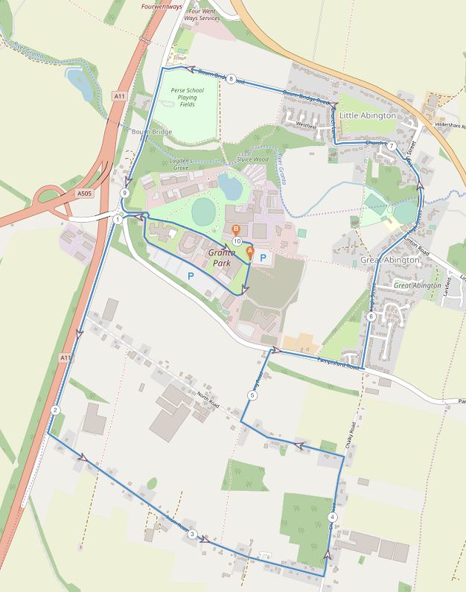

5K Course
- The 5k is a traffic free road race. The course has been officially measured with a road certificate and has distance markers every kilometre.
- The 5k course consists of 2 laps around Granta Park.
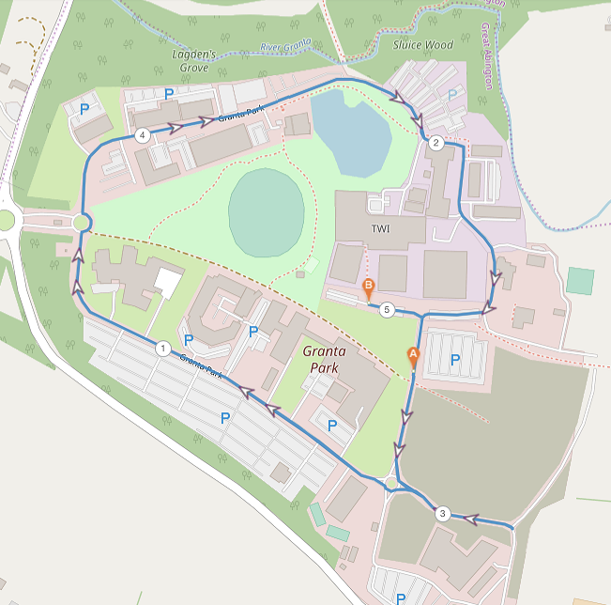

Fun Run
- The course of the Fun Run is one lap around part of Granta Park.

On the Start Line
- All runners are requested to assemble in the start area 10 minutes before the start.
- The start time for the 10k race is 10:30am and for the 5K and Fun Run at 10.45am. At the start we provide signs with expected race times. We ask all runners to line-up according to the signs showing their expected race times.
- Marshals will direct and assist all races. We are very grateful for these volunteers who have supported the races over many years and please be nice to them. Their instructions must be observed at all times.
- Unfortunately the courses are not suitable for wheelchair users or running with buggies and are not permitted.
- Running with dogs on any course is not permitted
- Headphones including Bone Conduction headphones and similar are not permitted on any course
- Minimum age for the Fun Run is 2 years, for the 5K it is 11 years and for the 10K it is 15 years.
Post-Race Refreshments
Subject to any Covid or other restrictions refreshments will be provided in the finish area

Results and Race Categories

Results (chip times) will be available online at https://www.racetimers.co.uk/. A link will be provided on the website shortly after the event.

Race Categories and Prizes
Men 5K  1st, 2nd & 3rd overall winner - trophies and mugs  1st Veteran 40+ - mugs  1st Veterans 50+ - mugs  1st Veterans 60+ - mugs  1st Veterans 70+ - mugs  1st Veterans 80+ -mugs  1st Abington/Hildersham Resident - mugs  1st Granta Park Championship - mugs | Women 5K  1st, 2nd & 3rd overall winner - trophies and mugs  1st Veteran 30+ - mugs  1st Veterans 40+ - mugs  1st Veterans 50+ - mugs  1st Veterans 60+ - mugs  1st Veterans 70+ - mugs  1st Abington/Hildersham Resident - mugs  1st Granta Park Championship- mugs
Men 10K  1st, 2nd & 3rd overall winner - trophies and mugs  1st Veteran 40+ - mugs  1st Veterans 50+ - mugs  1st Veterans 60+ - mugs  1st Veterans 70+ - mugs  1st Veterans 80+ - mugs | Women 10K  1st, 2nd & 3rd overall winner - trophies and mugs  1st Veteran 30+. - mugs  1st Veterans 40+ - mugs  1st Veterans 50+ - mugs  1st Veterans 60+ - mugs  1st Veterans 70+ - mugs
Men’s 10k  10K Club Cup - the first three male runners in a team specified before the event regardless of age or sex will count towards the results. The lowest combined time wins the trophy. | Women’s 10k  10K Club Cup - the first three female runners in a team specified before the event regardless of age or sex will count towards the results. The lowest combined time wins the trophy.
Boys Fun Run  All Great Abington School Year Groups 1st / 2nd /3rd – Certificates  Male 1st / 2nd /3rd – Trophies and Mugs | Girls Fun Run  All Great Abington School Year Groups 1st / 2nd /3rd – Certificates  Female 1st / 2nd /3rd – Trophies and Mugs

Privacy
We would like to take this opportunity to point out that Granta Park and TWI have kindly agreed to let us use their grounds solely for the purpose of the race.
Disclaimer
Please see and read the disclaimer document on the web site under the documents section.

2024 Cancellation Policy
The Abington 10k, 5K and Fun Run event is a community event run by Great Abington Primary School PTFA, a registered charity, for the benefit of the School. It has over the years become a very popular event for runners and has raised considerable funds for the School. In the unfortunate event that the event has to be cancelled we regret that we will be unable to refund entry fees or defer them to another year because of the costs that will already have been incurred. Any surplus (if any) will go to the School.
Any questions?
- Please email Abington10k@gmail.com
- We welcome comments/suggestions to improve future events.

Finally

- Enjoy the race!
- Thank you for your support of Great Abington Primary School

Many Thanks to Our current sponsors
Please contact Abington10K@gmail.com if you want to sponsor this event
Current Sponsors:

Great Abington Primary School PTFA
30/11/2023

